CNS 1410 Object-oriented Programming

Programming Project 11: Hourly Employee Report

Due Date:
Must be submitted no later than 1:00am on Monday.
Programs received prior to 1:00am on Sunday will receive 5 bonus points, if the program completely meets the specifications and executes correctly.

Objective:
This project will give students experience using generic algorithms from the Standard Template Library.

Introduction
In this project, you will write a program that will print out a report on the hourly employees working for a fictitious corporation. The report should list the following items:
- The total number of hourly employees.
- The number of employees who did not turn in any hours this pay period.
- The number of employees who worked overtime (more than 40 hours) this pay period.
- The average number of overtime hours worked during the pay period.
- The maximum number of hours worked by any employee this pay period.

Project Specifications
Your program should work as follows:
- It should prompt the user for a filename for a file containing the number of hours worked by each employee this pay period.
- It should store these values in a vector.
- Once all of the data has been read, your program should calculate the data for the report, as outlined above. All calculations should be done using generic algorithms from the Standard Template Library.
- The report is displayed on the screen.
Format and document your code in accordance with the course style guidelines. Include a file prologue identifying you as the author. Submit your project using the instructions outlined in the Course Syllabus, Programming Projects section.

File(s) to Submit:
- All source code files and an executable file.

Grading
The Grade sheet is here

Sample Output:
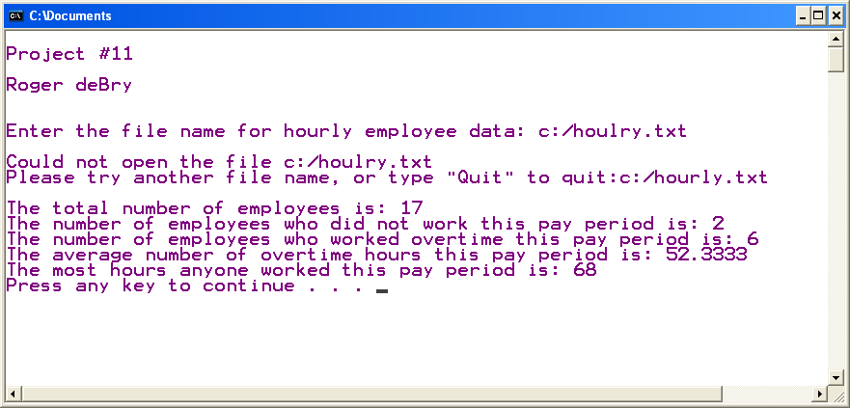

Sample executable
A sample executable can be found here.
A sample data file can be found here.

